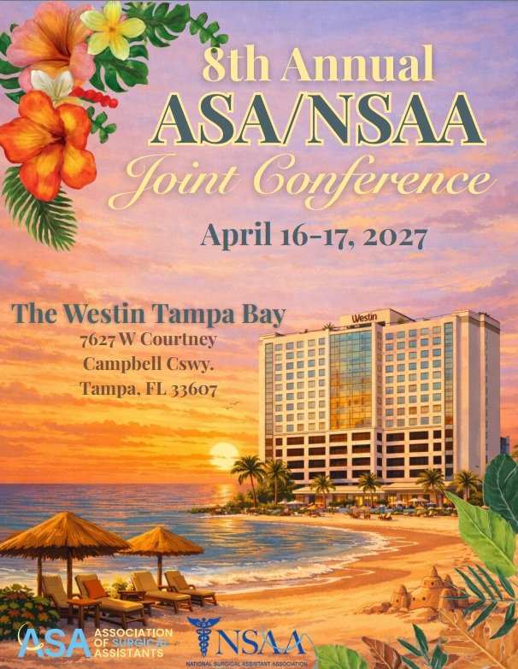
Exhibitor Information
Prospectus

Exhibit Information
April 16–17, approximately 125–150 highly engaged surgical assistants from across the country will gather in Tampa, Florida at The Westin Tampa Bay for the 8th Annual ASA/NSAA Joint Conference. Attendees come ready to learn, connect, and immerse themselves in cutting-edge education designed specifically for the surgical assistant profession. The exhibit hall serves as a dynamic extension of the educational experience, giving attendees the opportunity to explore innovative products, technologies, and services that enhance surgical efficiency and improve patient care. ASA and NSAA proudly sponsor this conference to promote continuing education, collaboration, and advancement within the surgical assistant profession. Information presented through exhibits, demonstrations, and promotional materials is provided solely by exhibitors and presenters and is not independently verified or endorsed by ASA or NSAA.

Exhibit Space
Standard exhibitor space includes one 6’ table and two chairs. Additional chairs can be purchased for $200 each and include conference meals and reception. Exhibit space not claimed or occupied by 6:00 PM on Friday, April 16, without prior arrangements with ASA or NSAA, may be reassigned without refund or reassignment obligation. Tables must be professionally covered and exhibitors may not assign, sublet, or share exhibit space without written approval.

Exhibit Space Policies
- Exhibits must support the professional and educational atmosphere of the conference.
- Displays must be professionally finished and safely assembled.
- Signs and banners must be independently supported.
- Live or video demonstrations must not disrupt neighboring exhibitors or conference activities.
- Storage of crates, boxes, or packing materials should be under the exhibitor’s table. Storing items behind booths is prohibited by City of Tampa Fire Code regulations and will be strictly enforced. Exhibitors requiring additional storage should coordinate directly with The Westin Tampa Bay.
- Exhibitors are responsible for maintaining clean and orderly exhibit spaces and returning the area in its original conditions. Excess debris, bulk printed materials, or large waste items must be removed by the exhibitor. Any incidentals associated with excessive waste removal may be charged to the exhibitor.

Exhibitor Badge Policy
Exhibitor badges will be available for pickup at the registration desk. Badges are intended only for authorized exhibitor representatives and must be worn at all times within conference areas. Additional company-issued badges are permitted; novelty ribbons or unauthorized attachments are not allowed on official conference badges.

Parking
The Westin Tampa Bay is located at 7627 W. Courtney Campbell Causeway, Tampa, FL 33607, approximately three miles from Tampa International Airport. Discounted self-parking is available for $15 per day with in/out privileges. Valet parking is available for $35 per day. Rates are subject to change based on prevailing hotel pricing. On-site electric vehicle charging stations are available.

Schedule of Events
All functions of the 2027 ASA/NSAA Joint Conference will be held at The Westin Tampa Bay located at 7627 W. Courtney Campbell Causeway, Tampa, FL 33607.
Tentative Schedule
Friday April 16th:
12:00—7:00 pm Registration at the Westin Tampa Bay
7:00—4:30 pm Hands-on Workshops
5:00—5:30 pm ASA/NSAA State of the Associations Meeting
5:30—6:30 pm Keynote Address
6:30—8:30 pm Reception with Exhibitors

Saturday April 18th:

7:30—9:00 am Registration at the Westin Tampa Bay
7:30—7:45 am Breakfast with Exhibitors
7:45—8:00 am Joint Welcome
8:00—09:50 am Scientific Presentations
09:50—10:10 am Professional Networking (Break with Exhibitors)
10:10—12:00 pm Scientific Presentations
12:00—1:30 pm Luncheon
1:30—3:20 pm Scientific Presentations
3:20—3:40 pm Professional Networking (Break with Exhibitors)
3:40—4:30 pm Scientific Presentations
4:30—5:00 pm Legislative Round Table on Current Issues & Trends

Meals and Lodging
Exhibitors will receive (2) meal tickets per booth space purchased at $1,500. This will include the Reception on Friday April 16th, Continental Breakfast, Lunch, and all breaks on Saturday April 17th. Extra booth seats are available for $200 each and include an additional meal ticket. The Reception and Lunch will be held onsite at The Westin Tampa Bay.

Booth Space at The Westin Tampa Bay
Exhibit Booth Space at The Westin Tampa Bay will be in the Foyer and Caribbean A&B, adjacent to the Caribbean Ballroom. Registration will also be located in the Foyer. Exhibitors that will be involved in the “Hands-On” Workshops on Friday will be assigned a location for the workshop prior to the conference.
Exhibit setup/breakdown times are as follows:
Exhibit Dates and Times:

Setup:
Friday, April 16: 10 am - 4 pm

Show Hours:
Friday, April 16: 5 pm - 8:30 pm
Saturday, April 17: 7 am – 5 pm Move out:
Saturday, April 17: 5 pm - 6pm

Shipping/Packages
The Receiving Department will accept boxes/packages for arrival at a maximum 48 hours prior to group arrival and must be marked with the responsible party’s name, Group Name, and “Hold for Arrival Date of (Day and Date)”. There will be a handling charge.

For pallet deliveries, prior approval must be obtained; otherwise, the hotel reserves the right to refuse delivery. Hotel staff will not assist in breaking down pallets.

The Sales Office must be notified in advance to ensure proper acceptance of these items. Boxes left behind beyond one week will be discarded. Please make prior arrangements as well to have your boxes returned to your company. Below is the format for addressing all packages being shipped to the hotel:
Attn: (include name of on-site representative responsible for boxes)
The Westin Tampa Bay
7627 W. Courtney Campbell Causeway
Tampa, FL 33607
(Group Name: Association of Surgical Assistants/National Surgical Assistant Association)
The hotel will not be held responsible for packages that are not properly labeled.

Hotel Information
The Westin Tampa Bay is located at 7627 W. Courtney Campbell Causeway, Tampa, FL 33607, situated on Tampa Bay and just three miles from Tampa International Airport. All room rates are exclusive of applicable state and local taxes, currently 13.5%. Rates will be available (3) days prior and (3) days after the Event Dates, subject to availability of guest rooms at the time of reservation.

Reservations with an ASA/NSAA Conference Room Rate of $229.00 may be made via this link:

ASA/NSAA Joint Conference or Group Code: ASA/NSAA
or from The Westin Tampa Bay link on ASA or NSAA’s website www.asa-nsaa.org. Reservations are also available by calling 1-813-281-0000 and reference the 2027 ASA/NSAA Joint Conference. Rooms are limited and expected to fill quickly. We encourage you to book your accommodations as soon as possible. The final day to reserve your room is March 18, 2026.
The Westin Tampa Bay’s amenities include On-Site Restaurant, Starbucks, Fitness Center, Water Sports Rentals, and Private Beach.

Association of Surgical Assistants
1750 H. Street, NW, Suite 360
Washington, DC 20006
Phone: 1-202-587-5793
E-mail: boardofdirectors@surgicalassistants.org • Website: www.surgicalassistant.org

NATIONAL SURGICAL ASSISTANT ASSOCIATION
1750 H. Street, NW, Suite 360
Washington, DC 20006
Toll Free: 1-855-270-6722
E-mail: info@nsaa.net • Website: www.nsaa.net

